**MCA LABORATORIES**

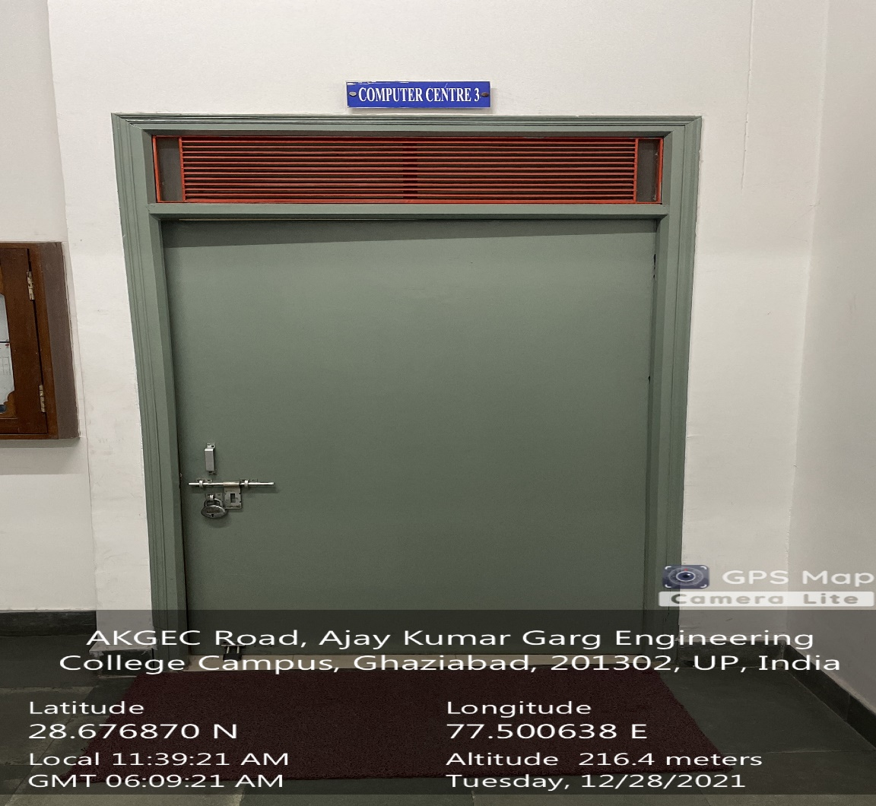

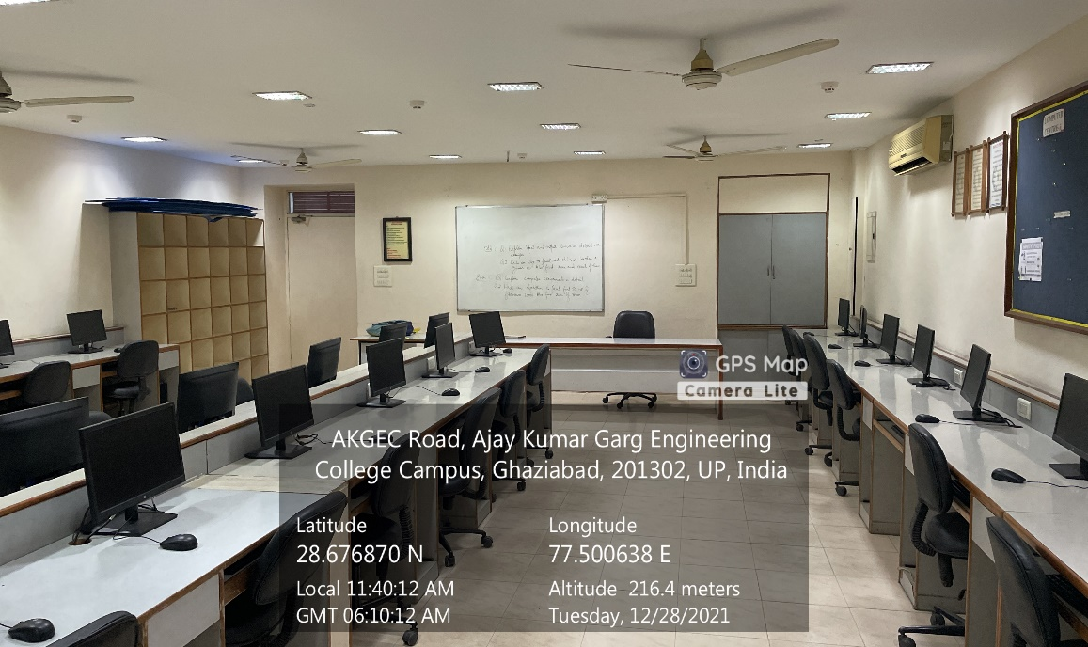

**ADMINISTRATIVE BLOCK BASEMENT, DATA STRUCTURES LAB**

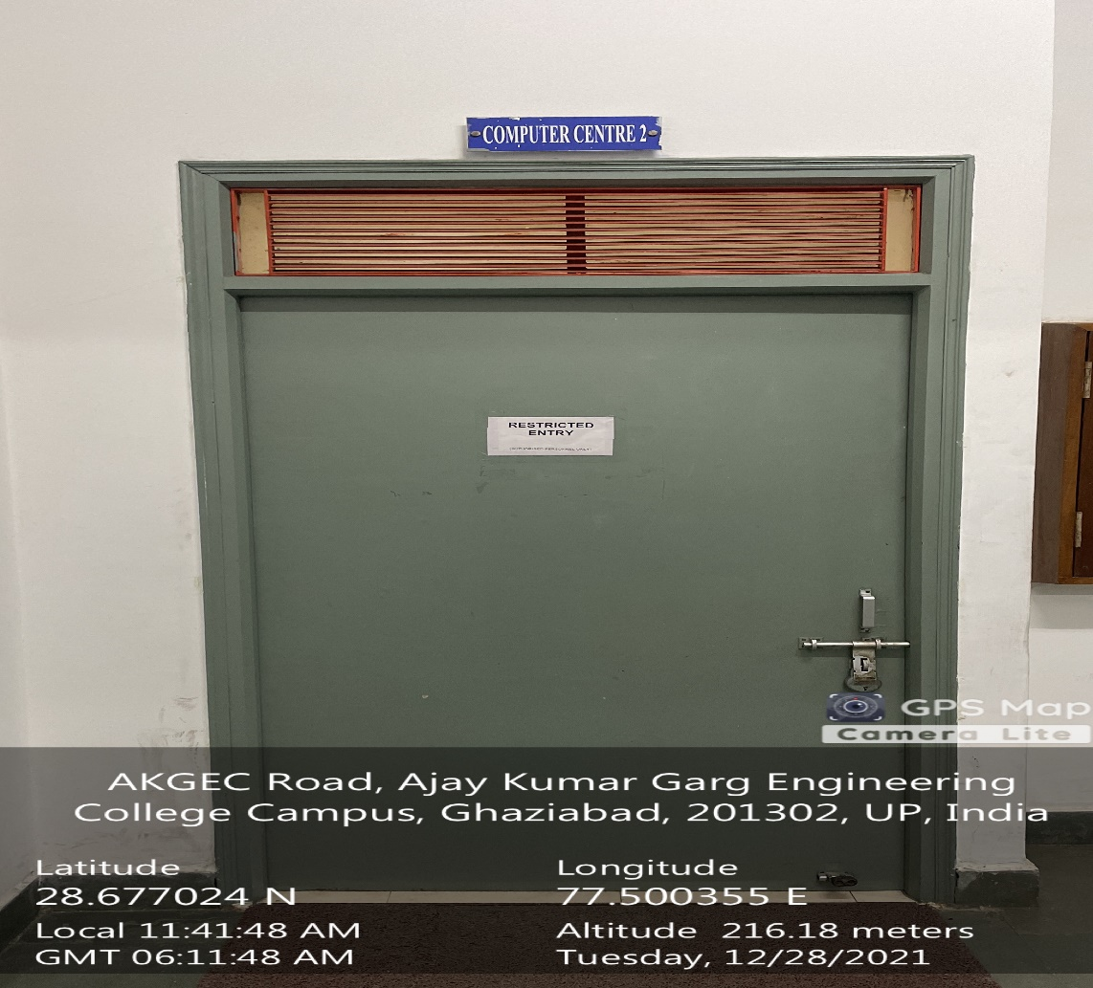

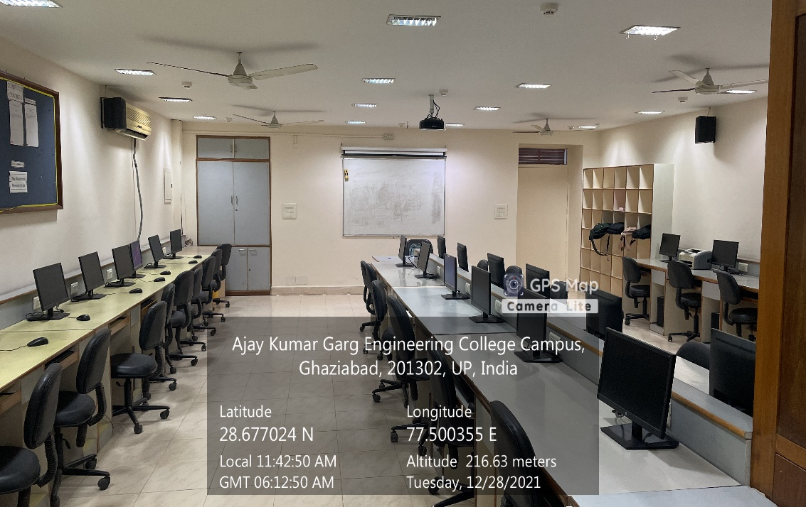

**ADMINISTRATIVE BLOCK BASEMENT,ADVANCE PROGRAMMING LAB**